UK ME/CFS Biobank Application (Outline)

September 2017

Prepared by CureME and UK ME/CFS Biobank at the London School of Hygiene & Tropical Medicine
Funded by NIAID (NIH), ME Association, ME Research UK and Action for M.E.
Date printed: August 2016
Copyright: London School of Hygiene & Tropical Medicine

London School of Hygiene & Tropical Medicine
Keppel Street, London, WC1E, 7HT, UK

t +44(0)207 927 2972
w cureme.lshtm.ac.uk
@mecfsbiobank

Contents

Background Information………………………………………4
Summary Information Sheet ...............................................5
Workflow................................................................................8
APPLICATION FORM 1 – Outline of Research Proposal.................................................................................9

Background Information

Academic, non-commercial, and commercial researchers will be eligible to apply to use samples and/or data from the UK ME/CFS Biobank if they present a sound scientific rationale for the proposed study and have a good research track record. Eligible researchers must be supported by their institution.
All research proposals intending to use samples from the UK ME/CFS Biobank must be developed in line with the Biobank’s mission. Proposals intending to develop the following types of studies will be prioritized:
  - testing or generating new hypotheses on the mechanisms (pathophysiology) of ME/CFS,
  - improving diagnosis (biomarkers) and phenotyping, and/or,
  - basic science, e.g. pharmacological in vitro studies potentially leading to clinical trials on therapeutic approaches.

The UK ME/CFS Biobank holds aliquots of the following blood derivates:

serum (0.2ml), plasma NaHep (0.25ml), plasma EDTA (1ml), whole blood (0.5ml), peripheral blood mononuclear cells (PBMC – 1ml with 5x10⁶ cell), granulocytes pellet (2ml), and PAXgene blood RNA tubes.

Availability of aliquots will be subject to previous usage by researchers.

Summary Information Sheet

Procedure for obtaining the UK ME/CFS Biobank’s samples and/or data

Who can get access to the samples and/or data?
Academic and commercial researchers will be eligible to apply to use samples and/or data from the UK ME/CFS Biobank if they present a sound scientific rationale for the proposed study and have a good research track record. Eligible researchers must be supported by their institution.

All research proposals intending to use samples from the UK ME/CFS Biobank should be developed in line with the Biobank’s mission; proposals intending to develop the following types of studies will be prioritized:
  - testing or generating new hypotheses on the mechanisms (pathophysiology) of ME/CFS,
  - improving diagnosis (biomarkers) and phenotyping, and/or,
  - basic science, e.g. pharmacological in vitro studies potentially leading to clinical trials on therapeutic approaches.

Steps to apply for access to samples and/or data

- Step 1 – Submission of an Outline Research Proposal
Researchers must submit an outline research proposal to the UK ME/CFS Biobank scientific subcommittee of the “Sub-Bank Guardian Board” (SBGB) using the outline application form (Application Form 1).

Forms should be submitted electronically to: mecfsbiobank@lshtm.ac.uk . The SBGB will review the application and aim to notify the applicant of their decision within two weeks. If the outline proposal is approved by the SBGB, the applicant will be invited to submit a full proposal (Stage 2). If you application is taken through to a Full Research Proposal you will be sent this application form.

- Step 2 – Submission of a Full Research Proposal
If the SBGB requests submission of a full research proposal, the applicants should submit their proposal using Application Form 2.

Submissions must:
o have a sound background,
o have a robust methodology which can be safely, ethically and effectively carried out in the institutions/ laboratories applying for samples,
o match hypotheses, objectives, and methods with available blood samples,
o statistically justify sample size, and
o if requesting additional data or blood test results, explicitly state what is needed and why.

At this stage, applicants should submit their projects to a Local Ethics Committee if they do not yet have local ethics approval (see WORKFLOW at page 5).

The Application Form 2 - Full Research Proposal will be reviewed by the UK ME/CFS Biobank scientific subcommittee. Specialty experts’ input will be sought as needed for studies outside subcommittee expertise. The researchers should expect a response from the scientific subcommittee within 4 weeks. Once the scientific subcommittee has agreed that the research proposal can proceed, approval from the Local Ethics Committee will be required. If there is a delay and the applicants do not have Local Ethics Committee approval by the end of the time interval for this step, a conditional approval can be issued. However, final approval for release of samples and/or data will be conditional on the presentation of applicable Ethics Approvals.

- Step 3 – Application to the UCL-RFH BioBank Ethical Review Committee (B-ERC)
Research applications considered suitable to proceed by the SBGB scientific subcommittee should fill out the form entitled “ REQUEST FORM FOR USE OF EXISTING SAMPLES/DATA FROM THE BIOBANK FOR RESEARCH ONLY” and submit it electronically. Please note that in this case, the LSHTM UK ME/CFS Biobank will provide the consent required on page 8 of the form. The B-ERC will take 2 to 3 weeks to consider the application.

- Step 4 – Signature of the Material and/or Data Transfer Agreements (MTA and/or DTA) by all parties

If approval is granted, the applicants should receive the Material Transfer Agreement (MTA) for signature. The MTA is a legal document that establishes that the ‘Recipient’ of the samples provided by the UK ME/CFS Biobank will use them appropriately and will dispose of remaining samples in accordance with the required procedures. Additionally, the MTA covers reporting, publication acknowledgments, and Intellectual Property (IP) issues. The MTA will be signed by London School of Hygiene & Tropical Medicine (‘LSHTM’) and The University College London – Royal Free Hospital BioBank (‘UCL-RFH’), where the UK ME/CFS Biobank samples are hosted, and the Principal Investigator or the Institution’s representative on behalf of the ‘Recipient’.

Additionally, if the ‘Recipient’ requests data related to the samples a Data Transfer Agreement (DTA) between the LSHTM and the Recipient will be issued for signature. We anticipate this step will take 4 to 8 weeks to be completed.

- Step 5 – Shipment of samples and/or transference of data to the ‘Recipients’
Once the MTA/DTA(s) is(are) signed by the parties, the teams at the UCL/RFH BioBank and the LSHTM as applicable will prepare the required samples and/or data to be shipped and/or transferred. The Recipient will receive the samples and/or data within one week of signature of the relevant agreements.

Fees:
The UK ME/CFS Biobank services are provided on a cost recovery basis. Applicants can obtain quotes for batches of blood derivative samples and/or dataset from the Biobank team (mecfsbiobank@lshtm.ac.uk).

Table 1 – Timeframe for applications to access samples and/or data

STEPS | Timing
- Submission of an Outline of Research Proposal to the UK ME/CFS Biobank Guardian Board (Sub Bank Guardian Board – SBGB) | 2 weeks
- Submission of a Full Research Proposal to the SBGB | 4 weeks
- Submission of the application to the UCL-RFH BioBank Ethical Review Committee (B-ERC) | 2 – 3 weeks
- Signature of Material Transfer Agreement and/or Data Transfer Agreement by all parties | 4 – 8 weeks
- Shipment of samples and/or transfer of data to the applicants | 1 week
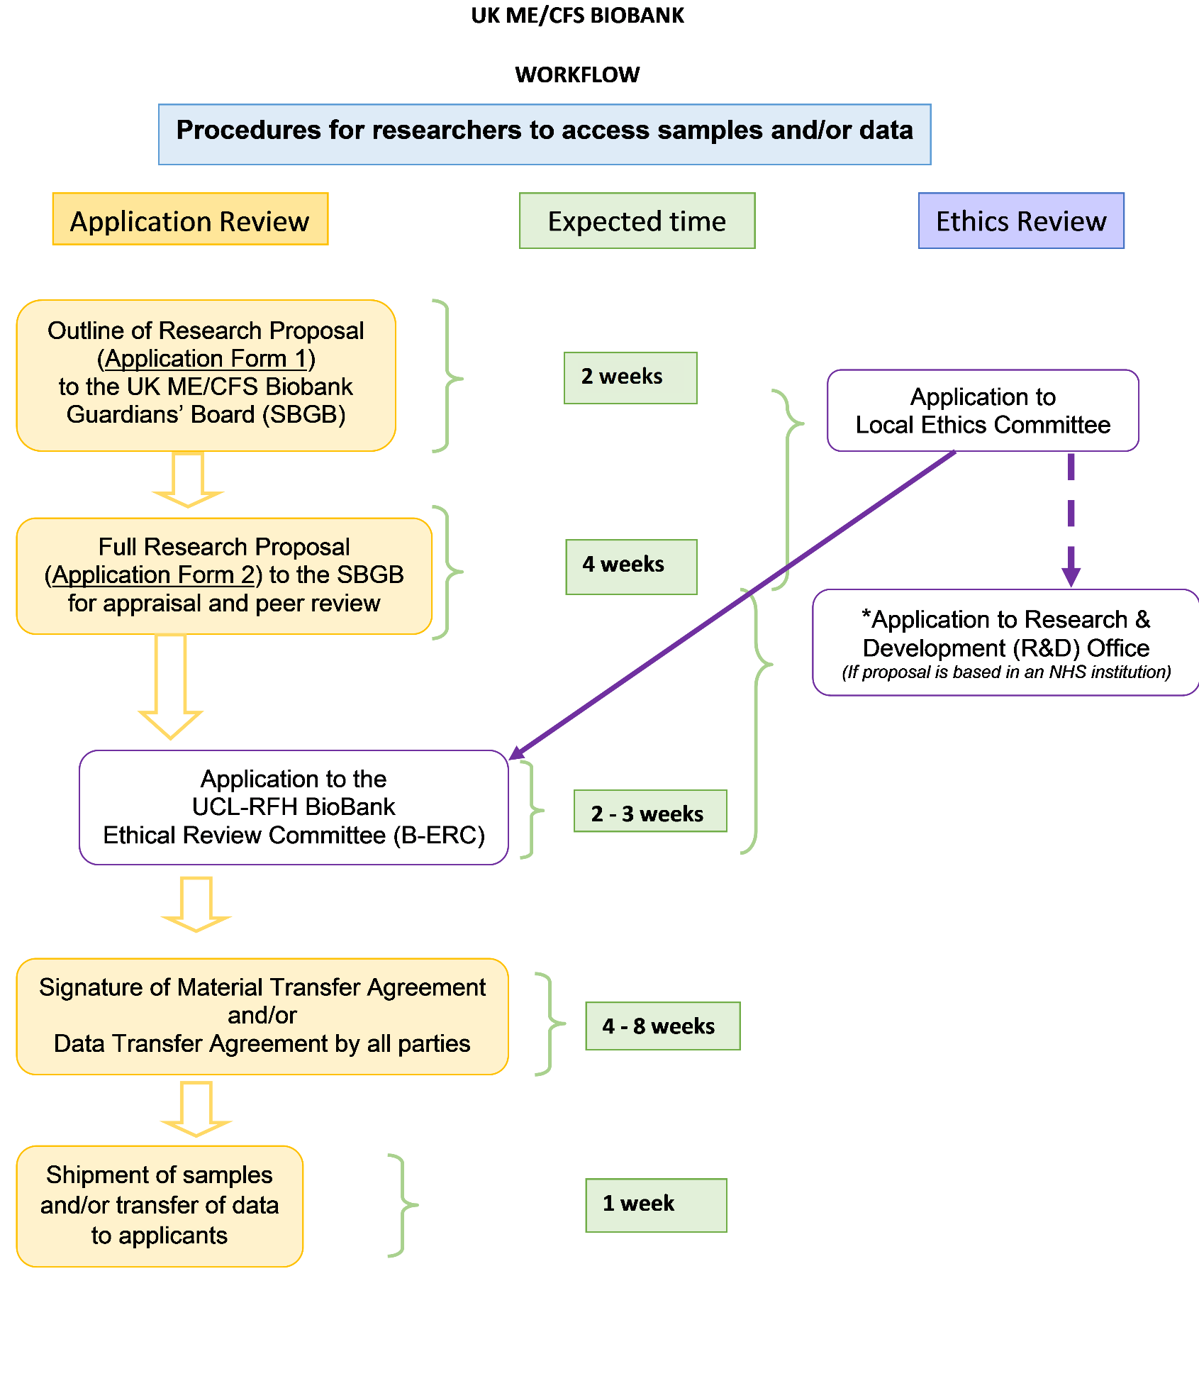

APPLICATION FORM 1 – Research Proposal Outline

Applicants should return the completed form to: mecfsbiobank@lshtm.ac.uk

Date of Application DD/MM/YY | / /

Applicant
Name of Principal Applicant
Title & Position of Principal Applicant

Name & Position of Co-Investigator(s)

Institution
Institution where research will be conducted
Address
Telephone N°, including country code
E-mail

Project title

Commercial/non-commercial intent
Does this research include any commercial interests? | (Yes/No)
If yes, please explain nature of commercial interests:
Outline of proposal
This must not exceed 1 single-spaced page (written in a minimum size 11 font (in Arial or Times New Roman). The proposal should be clear and concise and use the following sub headings: (i) title; (ii) brief background; (iii) objectives; (iv) methods - including materials, particularly samples and/or data required from the UK ME/CFS Biobank; and (v) expected outcomes.

London School of Hygiene & Tropical Medicine
Keppel Street, London, WC1E, 7HT, UK

t +44(0)207 927 2972
w cureme.lshtm.ac.uk
@mecfsbiobank

The SBGB scientific subcommittee has three members and includes a patient, representative from an ME charity, and a member of the CURE-ME research group at LSHTM.

